How to Recognise When Dialysis May Be Necessary: Key Signs and Symptoms – H1
P1 | signs that you need dialysis
P2 | types of dialysis
P2 | side effects of dialysis in the elderly
P2 | dialysis side effects
P2 | complications of kidney dialysis
P2 | early signs of kidney failure
P2 | best dialysis center in pune

URL Slug: /recognizing-signs-when-dialysis-necessary
Title: Recognizing Key Signs When Dialysis May Be Necessary
Description: Learn about the signs that you need dialysis, the types available, and side effects. Early recognition can improve outcomes and quality of life in kidney failure.
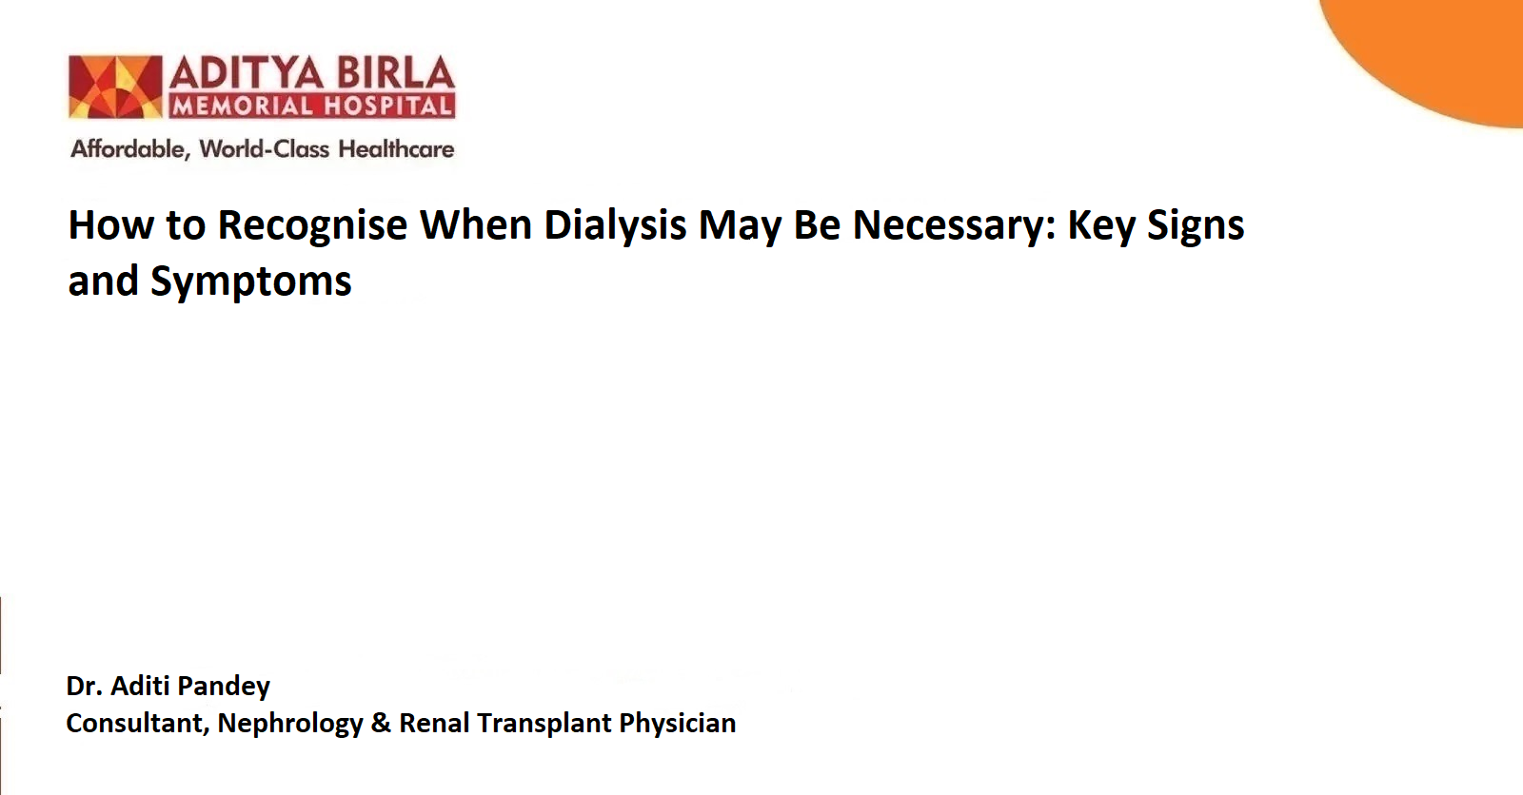

Kidney health is a crucial aspect of overall well-being, yet kidney-related conditions often progress silently, with noticeable symptoms emerging only in advanced stages. Dialysis is a life-saving treatment for patients who are suffering from kidney failure, but recognising the need for it early can significantly improve outcomes and quality of life. This guide delves into the signs that you need dialysis, the types of dialysis available, potential side effects, and how to navigate treatment effectively.
Understanding Kidney Function and Failure – H2
The kidneys are vital organs that help to filter waste, excess fluids, and toxins from the blood. When kidney function declines significantly, waste products build up in the body, leading to a condition known as End-Stage Renal Disease (ESRD). At this stage, dialysis becomes necessary to perform the filtering functions that the kidneys can no longer handle.
Early Signs of Kidney Failure – H2
Recognising the early signs of kidney failure is essential for timely intervention. If you know anyone experience these symptoms, it is crucial to consult a doctor for evaluation and possible intervention.
Symptoms are:
- Fatigue and Weakness: A build-up of toxins in the blood can cause persistent tiredness.
- Swelling (Edema): Excess fluid retention may result in swelling in the legs, ankles, feet, or face.
- Changes in Urination: Increased or decreased frequency, dark-coloured urine, or blood in urine.
- Shortness of Breath: Fluid build-up in the lungs can cause difficulty breathing.
- Nausea and Vomiting: Accumulation of waste products in the bloodstream may lead to digestive issues.
- High Blood Pressure: Damaged kidneys can contribute to uncontrolled hypertension.
Signs That You Need Dialysis – H2
Dialysis becomes necessary when kidney function drops below 15% or when symptoms of severe kidney failure develop. Key signs include:
Severe Fluid Retention: Persistent swelling in the body, especially around the lungs, causing breathing difficulties.
High Levels of Waste in the Blood: Symptoms such as nausea, vomiting, loss of appetite, and confusion.
Severe Fatigue and Weakness: The body struggles to function with high toxin levels.
Uncontrolled High Blood Pressure: Even with medications, hypertension may persist or worsen.
Heart-Related Issues: Irregular heartbeats or chest pain caused by imbalances in electrolytes like potassium.
Types of Dialysis – H2
Dialysis is categorised into two main types, each with distinct procedures and benefits:
1. Hemodialysis
This is the most common form of dialysis, where a machine filters waste and excess fluid from the blood. The process involves:
- Access through a fistula or graft in the arm.
- Sessions are typically conducted three times a week at a dialysis centre.
- Each session lasts about four hours.
- Hemodialysis is highly effective but requires regular visits to a treatment centre.
2. Peritoneal Dialysis
This type uses the lining of the abdomen (peritoneum) to filter blood. It involves:
- A catheter inserted into the abdominal cavity.
- Filling the cavity with a special fluid that absorbs waste and toxins.
- Draining the fluid after a few hours.
- Peritoneal dialysis offers more flexibility and can be done at home, making it ideal for individuals seeking a less restrictive lifestyle.

Side Effects of Dialysis in the Elderly – H2
While dialysis can prolong life, it may come with side effects, particularly in elderly patients.
Common side effects include:
- Low Blood Pressure: Caused by rapid fluid removal during treatment.
- Fatigue: Frequent sessions can be physically draining.
- Muscle Cramps: Resulting from shifts in fluid and electrolyte levels.
- Infections: Risk of infections at the access site or in the peritoneum.
- Nutritional Deficiencies: Protein loss during dialysis can lead to malnutrition.
- Careful monitoring and personalised care plans can help manage these side effects effectively.

Complications of Kidney Dialysis – H2
While dialysis is life-saving, it can lead to certain complications, such as:
- Access Site Problems: Blockages or infections at the fistula or catheter site.
- Electrolyte Imbalances: Irregularities in potassium, calcium, or phosphorus levels.
- Heart Issues: Increased risk of cardiovascular events due to fluid shifts and electrolyte changes.
- Dialysis Disequilibrium Syndrome: Rare but serious, involving nausea, headache, and confusion during or after treatment.
Regular follow-ups with a healthcare team can help mitigate these complications.

The Importance of a Reliable Dialysis Center – H2
Choosing the right dialysis centre is critical for ensuring effective and comfortable treatment. If you are in the Pune area, consider visiting the best dialysis centre in Pune, such as Aditya Birla Memorial Hospital. Renowned for its state-of-the-art facilities and experienced doctors, the centre provides personalised care tailored to each patient’s needs.
How to Prepare for Dialysis – H2
Starting dialysis can be overwhelming, but adequate preparation can make the transition smoother:
- Educate Yourself: Understand the procedure, benefits, and potential challenges.
- Follow Dietary Guidelines: Adhere to a kidney-friendly diet to manage fluid and electrolyte levels.
- Build a Support System: Seek emotional and practical support from family, friends, or patient groups.
- Maintain Physical Activity: Light exercise can improve overall health and well-being.
Can Dialysis Be Avoided? – H2
In some cases, early intervention and lifestyle changes can delay the need for dialysis. Steps include:
- Managing Blood Pressure and Diabetes: Control these conditions to slow kidney damage progression.
- Adopting a Healthy Diet: Limit salt, protein, and potassium intake.
- Staying Hydrated: Drink adequate water unless advised otherwise by a doctor.
- Regular Check-Ups: Frequent monitoring can detect kidney issues early.
When to See a Doctor – H2
- Consult a nephrologist promptly if you experience:
- Persistent swelling or shortness of breath
- Unexplained fatigue or confusion
- Changes in urination patterns
- Signs of high blood pressure or heart issues
Early detection and timely treatment can improve outcomes and delay the progression of kidney disease.
Conclusion – H2
Dialysis is a vital treatment for individuals with kidney failure, but early recognition of symptoms and proactive management can make a significant difference. Understanding the types of dialysis, potential side effects, and complications helps patients and caregivers make informed decisions. If you or a loved one is facing kidney-related issues, seek professional advice and consider trusted facilities for comprehensive care.

Frequently Asked Questions (FAQs) – H2
- How does a doctor determine if a person needs dialysis?

Doctors use a combination of tests, including blood tests to measure creatinine and blood urea nitrogen (BUN) levels, urine tests, and imaging studies. The decision is often based on your glomerular filtration rate (GFR), which measures kidney function, and the presence of severe symptoms.
- Can dialysis be temporary?
Yes, in some cases, dialysis is temporary, such as during acute kidney injury (AKI), where kidney function may recover. However, for chronic kidney disease (CKD) or end-stage renal disease (ESRD), dialysis is often a long-term solution unless a kidney transplant is performed.
- Are there any alternatives to dialysis?
A kidney transplant is the primary alternative to long-term dialysis. Additionally, in early stages of kidney disease, medications, lifestyle changes, and dietary modifications may help delay the need for dialysis.
- Can dialysis completely replace kidney function?
No, dialysis mimics some functions of healthy kidneys but does not completely replace them. It primarily helps remove toxins and regulate fluid and electrolyte balance.
- Is it possible to work or travel while on dialysis?
Yes, many patients continue to work and travel while on dialysis. Portable dialysis machines and flexible treatment schedules make it possible to maintain an active lifestyle.

References:
- Good to Know: Kidney Disease: Signs and Treatment. Clinical Diabetes. 2020 Apr;38(2):201–3.
- Whaley-Connell A, Ravi Nistala, Chaudhary K. The Importance of Early Identification of Chronic Kidney Disease. Missouri Medicine [Internet]. 2015;108(1):25. Available from: https://pmc.ncbi.nlm.nih.gov/articles/PMC6188457/
- Abdel-Kader K. Symptoms with or because of Kidney Failure? Clinical journal of the American Society of Nephrology: CJASN [Internet]. 2022 Apr 1 [cited 2023 Apr 15];17(4):475–7. Available from: https://pubmed.ncbi.nlm.nih.gov/35246459/

